DataCo RETAIL SALE - NPower JDA
_________________________________________________________________________________________________________
Name: Jerick T. Comedia
Gmail: comediajerick22@gmail.com
Phone: 09465481434
About Dataset
Synthetic retail sales dataset created for data analytics trainingnas part of the NPower Canada Job-Driven Training (JDA) program
Generative AI for Data Analysts module (Weeks 12–14).
Overview:
- 108 transactions, January-December 2024
- 4 regions: Central, East, South, West
- 3 categories: Electronics, Office Supplies, Software
- 4 sales reps: David Kim, James Lee, Maria Lopez, Sarah Chen
Columns: Date, Region, Category, Product, Units_Sold, Unit_Price, Total_Sales, Profit_Margin (decimal), Sales_Rep
Intended use: Generative AI workshops prompt engineering,
AI-assisted data storytelling, chart generation exercises.
Dataset link: https://www.kaggle.com/datasets/mohamedctraore/dataco-retail-sales-dataset-npower-jda

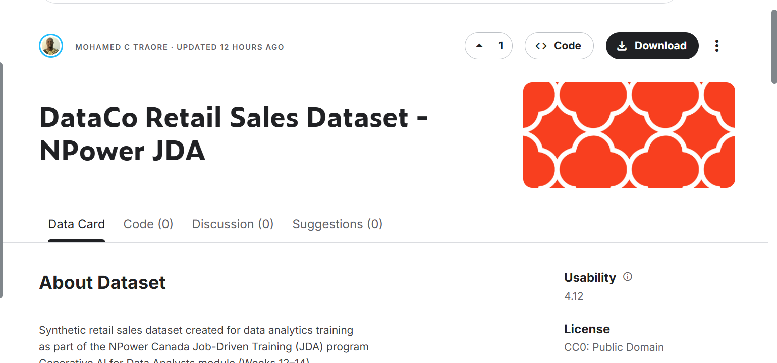

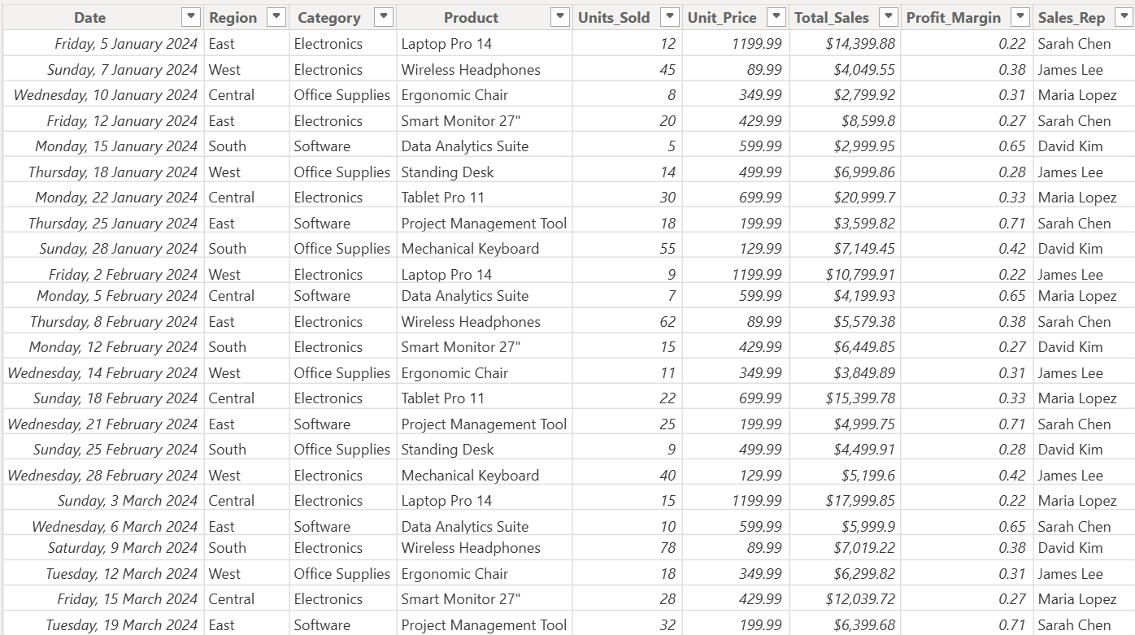

I loaded the dataset into Power bi for Analysis and list down the insight and created a chart for every insight
1. Create a KPI for Total Revenue, Total Sale, Profit Margin.
> Give an insight for DataCo Retail Sales
2. Create a chart for products and its sales
> In order to know the sales of the products
3. Create a chart for sales forecasting
> To find if there’s a trend for better decision making near the future
4. Create a chart for Category most solve.
> to determine what type of products is most solve for a better production
5. Create a chart of employee performance.
> Track who the best employee and to have an assessment for those has low sales
And lastly Recommendation and Insight for better decision.